# Read Me for ExpiredLah

**Li Yangnan(G1902136L)  
Email : [liya0036@e.ntu.edu.sg](mailto:liya0036@e.ntu.edu.sg)**

## What is ExpiredLah？

Sometimes people forget the details of their daily necessities, like the expired date of those products and the location where they put those products. That would cause a lot of wasting if one forgets to use those products. To avoid wasting, I designed these APP, To help users use their products in time.

## How to use it?

* Main page(current items)
* History items
* Adding item
* Editing item
* Removing item
* Removing all expired item
* Removing in history

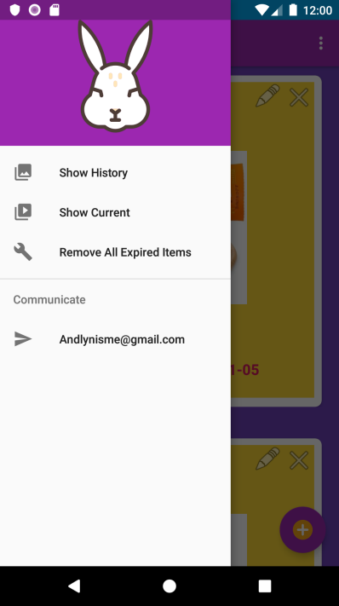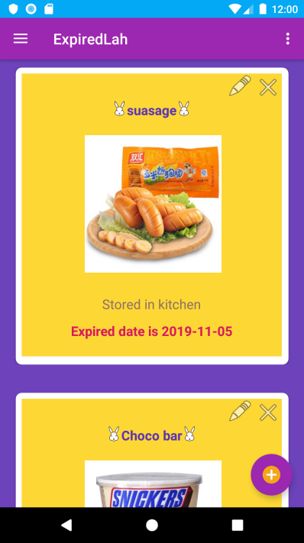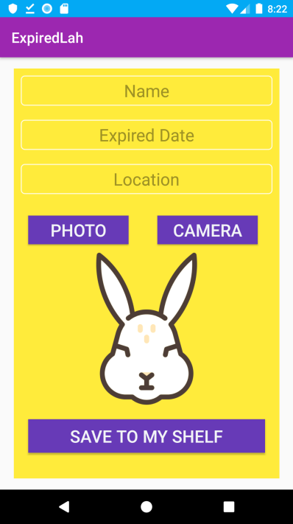

Basically, there are two important activities.

The first one is the main activity. It displays the products which are added by the user, and the items closer to its expired date than the others would be displayed on the top. If a user wants to remove the item, they can click the removing button on the right top side of the product card. Also, the item can be edited by click the editing button. The main activity has two mode, show current items and show history items, can be switched at the menu.

The second one is adding/editing product activity. While users click the adding button on the main page or the editing button on the item card, they would jump to the product adding/editing activity. Users can enter the name, Expired date, and location of the product. Also, users can take a photo or pick existed photo from the album to describe the product. At last, they can add the item to the main page by clicking the ‘save to my shelf’ button. And the items on the main page would refresh since the new item is added/edited.

## **How dose it work?**

1. The information of the product is saved in the SQLite Database. The structure of the product table is like below:

|  |  |  |  |  |
| --- | --- | --- | --- | --- |
| id | name | EXPdate | location | picture |
| varchar(36) | varchar(20) | date | varchar(20) | varchar(100) |

1. The data is retrieved from the database while the main page is loading. Each card showing the message of the product is realized by adding the fragment which contains a cardview to the linear container of the main page. While removing a product from the main page, the location of the record would be marked as “removed” by recognizing the id of the record, and the card loading function would be called again to refresh the main page.
2. When the user clicks the Expired date edit view, it would pop up a calendar to let user choose the date, and the value the user chooses would return to the edit view. And if the user using the album or camera for the first time, the system would ask permission from the user. The picture user chooses from the album or taken by the camera would turn into a bitmap to be the source of the Image view. The data is inserted into the database when the user clicks the ‘save to my shelf’ button. And the card loading function would be called to refresh the main page.
3. To realize show history item function, the removed item’s location “removed” would be a mark to identify if the item is current item or history item.

## **Challenges**

* Creating fragments and adding content.
* Adding field to the data table.
* Getting the photo from the camera and turn it into bitmap.